CO-OP Academy Rathbone School Menu Cycle Week 3
*All meals are Halal unless otherwise stated *V = Suitable for vegetarians
*West Derby School kitchen cannot guarantee a completely allergen free site. *Co-op Academy Rathbone staff are responsible for managing children’s allergens and ensuring that meals selected are appropriate for them*
Morning Break (Monday – Friday)
Waffles
*(Allergen Information: Gluten, Milk, Eggs and Soya)
Croissant
*(Allergen Information: Gluten, Eggs, Milk, Soya, Tree nuts and Peanuts)

Lunchtime Menu
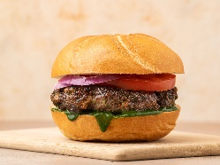  Monday | Burger Day  Beef burgers presented on a bun with tomato ketchup, fresh salad and served with Homemade Wedges  *(Allergen Information: Contains or may contain Gluten, Soya, Sesame Seeds, Sulphur dioxide & Sulphites)
Vegetarian Burger *V
Presented on a bun with mayonnaise, salad and served with Homemade Wedges
*(Allergen Information: Contains or may contain Gluten, Eggs, milk and, sesame seeds)
Tuesday  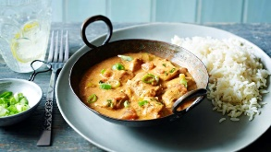 | Curry Day  Homemade Chicken Curry with Onions, Peppers, Boiled Rice and a Naan Bread  *(Allergen Information: Contains or may contain Gluten, Mustard, Nuts, Peanuts, Sesame Seeds)
Vegetable Samosa *V
Served with boiled Rice and a Naan Bread
*(Allergen Information: Contains or may contain Gluten, Nuts or Peanuts, Sesame Seeds)
Wednesday  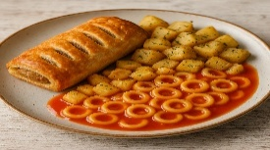 | Pork Sausage Roll *Non -Halal*  Served with Herby Diced Potatoes and Spaghetti hoops  *(Allergen Information: Contains or may contain Gluten, Milk)
Vegan Sausage Roll *V
Served with Herby Diced Potatoes and Spaghetti hoops
*(Allergen Information: Contains or may contain Gluten)
Thursday  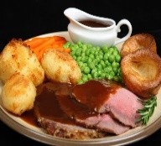 | Lamb Roast Dinner Day  Home roast leg of Lamb, Roast Potatoes, Fresh Broccoli, Julienne Carrots, and rich gravy.  *(Allergen Information: Contains or may contain Gluten, Soya)
Quorn Fillet Roast Dinner *V
Quorn fillet served with Sage & Onion stuffing, Roast Potatoes, Fresh Broccoli, Julienne Carrots, and rich gravy.
*(Allergen Information: Contains or may contain Gluten, Soya)
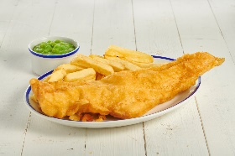  Friday  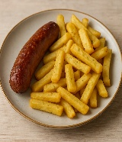 | Fish and Chips  A selection of classic dishes to choose from: Golden Battered Cod Fillets, Fish Cakes with Baked Beans.  *(Allergen Information: Contains or may contain Gluten, Fish)  or Sausages  *(Allergen Information: Contains or may contain Gluten, Soya, Sulphur dioxide & Sulphites)
Hot Chicken Wraps £1.90  *(Allergen Information: Contains or may contain celery, gluten)  or Panini £1.90  *(Allergen Information: Contains or may contain celery, gluten, sesame seeds)  with Sweet Chilli Sauce (Optional)  *(Allergen Information: None)  Sausage Rolls £1.60 *Non Halal*  *(Allergen Information: Gluten, Milk)  Pizza £1.60 *V  *(Allergen Information: Gluten, Milk)  Beef/Chicken Burger £1.60  *(Allergen Information: Gluten, soya, Milk, Celery, Sulphur dioxide & Sulphites)  Variety Boxed sandwiches £1.45  (Ham, Cheese *V, Tuna (*fish), chicken mayonnaise and egg mayonnaise *V)  *(Allergen Information: Please check box) |  | Available Every Day  Drinks  Water  Still Flavoured Water  *(Allergen Information: None)  Baked Goods  Cookies  *(Allergen Information: Gluten, Milk, Eggs)  Fruit  Choose from variety of fruit  Yoghurts  Choose from variety of flavours  *(Allergen Information: Milk) |  | Drinks  Water  Baked Goods  Cookies  *(Allergen Information: Gluten, Milk, Eggs)  Donuts  *(Allergen Information: Gluten, Milk, Nuts or Peanuts)  Fruit  Choose from variety of fruit  Yoghurt  Choose from variety of flavours

